 +123-456-7890
 hello@reallygreatsite.com www.reallygreatsite.com
 123 Anywhere St., Any City, ST 12345

 Education

2020 - 2022 Fashion School
Borcelle University Already made all the styles for all
seasons and made all the designs to be more sold.

2020 - 2022 Fashion School
Borcelle University Already made all the styles for all
seasons and made all the designs to be more sold.

 Experience

2020 - 2022
Salford Company

Fashion Manager
Already made all the styles for all seasons and made all the designs to be more sold.

2020 - 2022
Salford Company
Fashion Manager
Already made all the styles for all seasons and made all the designs to be more sold.

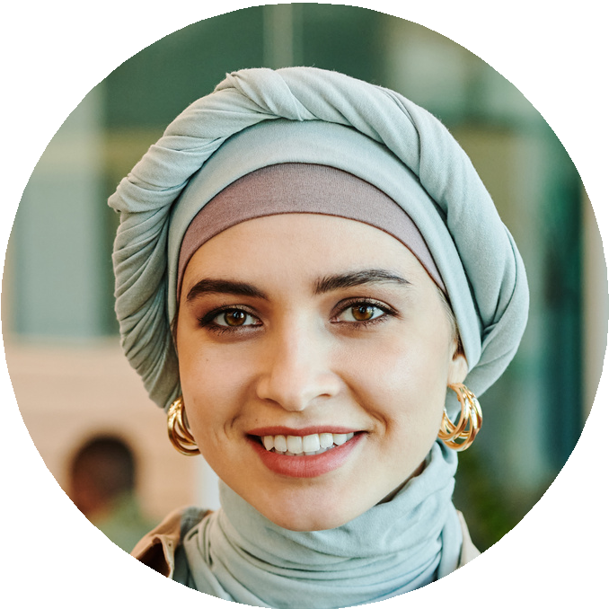2020 - 2022
ALFREDO TORRES
FASHION DESIGNER
About Me
Let me introduce myself, I am a fashion designer who has 7 years of experience in this job. I am very experienced in various fashion styles for all seasons and I have made various models for men and women for a world famous
brand.
LANGUAGES
English
Russian
Dutch

German
Salford Company

 Expertise
Design Sewing Blogging Music
Fashion Manager
Already made all the styles for all seasons and made all the designs to be more sold.

Design Sewing Blogging Music

